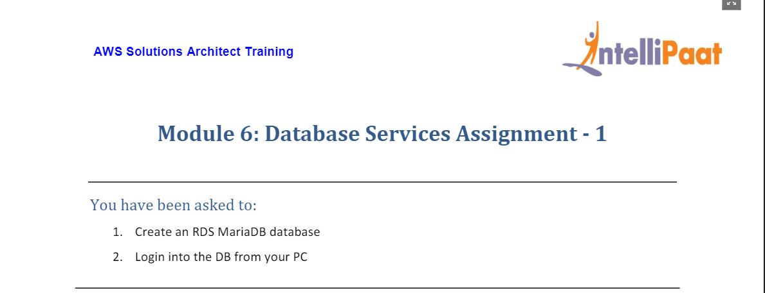

1. Choose RDS Service on AWS Console

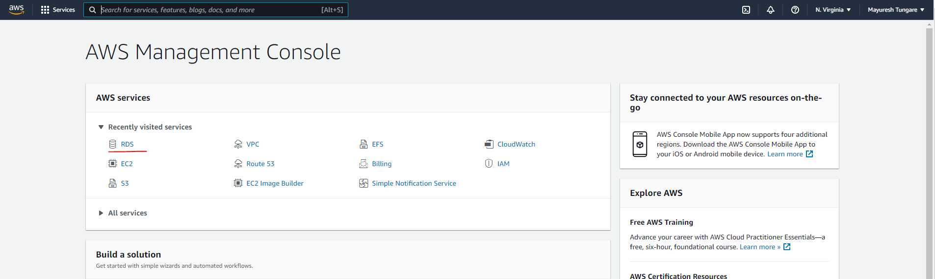

1. Choose Create Database option

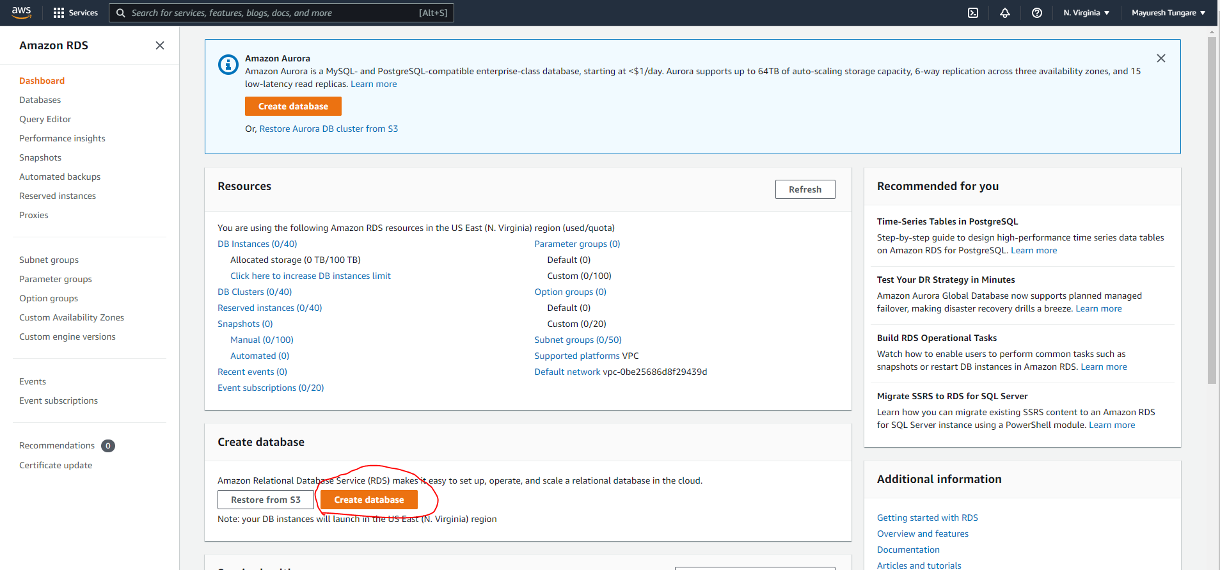

1. Choose the following options – Easy Create, MariaDB and Free tier (to avoid charges). Note you will need to choose user and password.

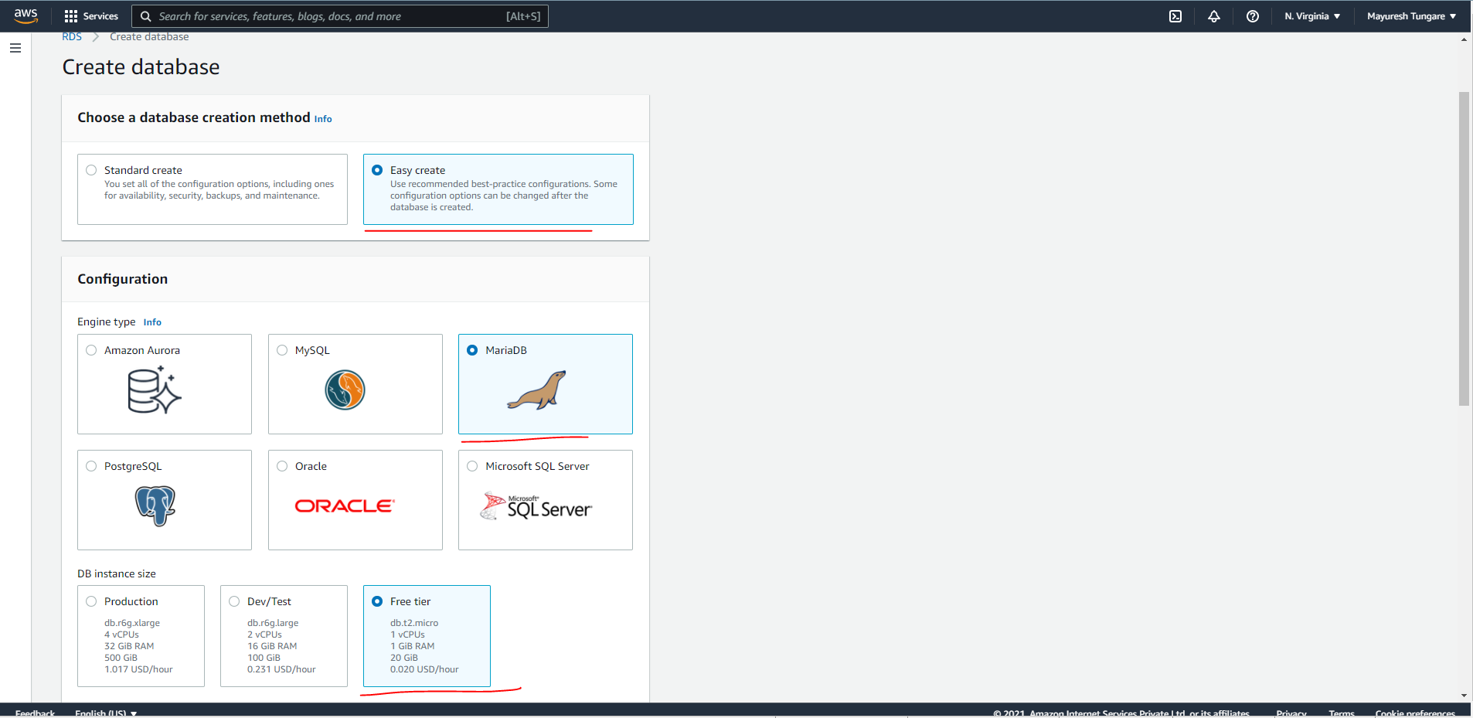

1. Once you click on Create database, the database will be created as follows. Please note DB creation process takes time (about 5-7 minutes):

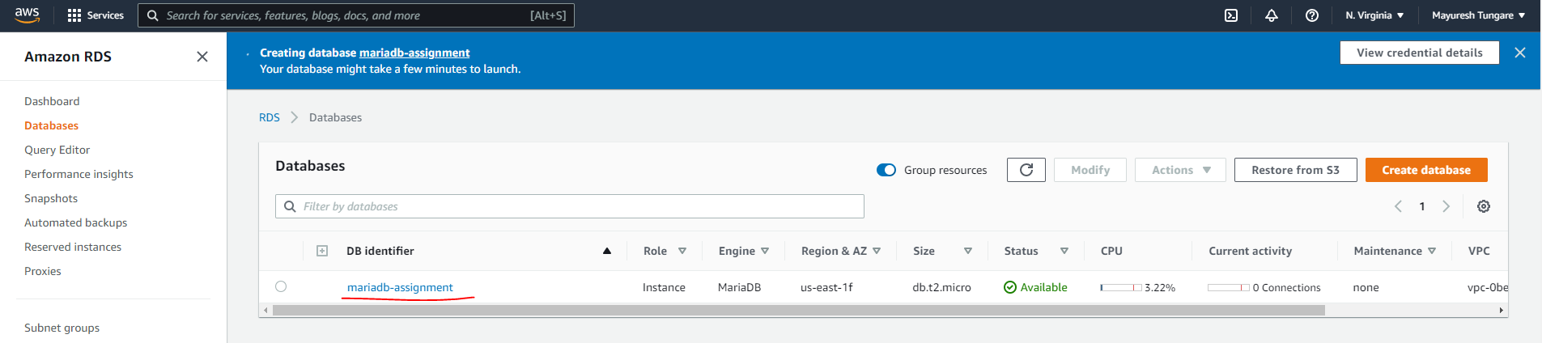

1. Please make a note of the Endpoint and port you will need to connect the instance to.

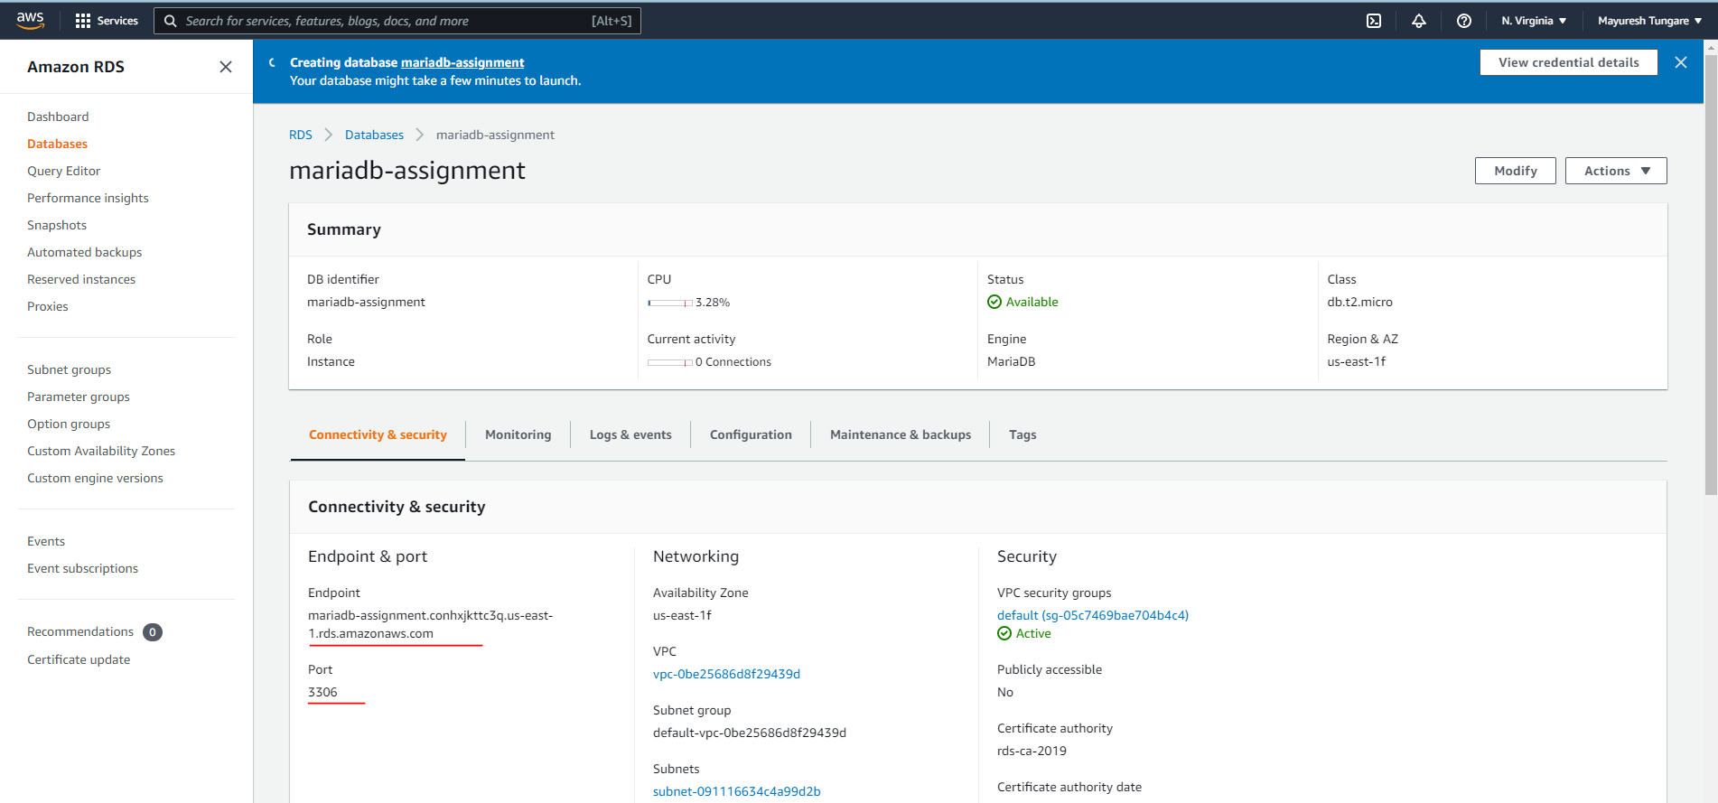

1. Please ensure the security group allows inbound SSH into the DB.

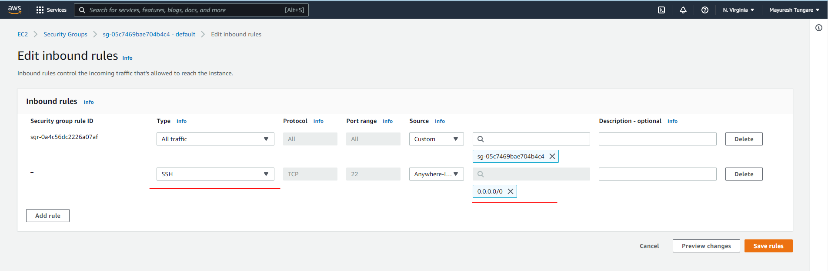

1. Open an Ubuntu (Linux) terminal on your workstation and enter the following command to ensure you have the SQL packages installed



1. Enter the following command to logged onto your MariaDB using credentials created in earlier step



1. You have now logged onto your MariaDB

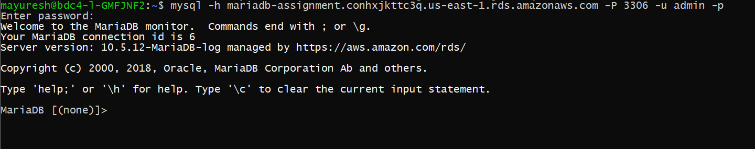

1. The assignment is now complete.